(Approx. 1426 words)

LibreOffice
By Dick Maybach, Member, Brookdale Computer Users’ Group, NJ
August 2016 issue, BUG Bytes
www.bcug.com
n2nd (at) att.net

LibreOffice originated in Germany in 1993 as Star Office, which became OpenOffice, first under Sun Microsystems and later under Oracle. In 2010 a group of developers, unhappy with Oracle's management of the project, formed the Document Foundation, and used the OpenOffice code as a basis for LibreOffice. Oracle later donated OpenOffice to the Apache Software Foundation, where its development appears to be lagging behind the vigorous pace of LibreOffice. Although LibreOffice and MS Office do similar tasks, their operating details differ considerably. If you have used MS Office for a long time, then your first experience with LibreOffice will probably leave you frustrated with illogical menus and unpredictable operation. I've used LibreOffice for years (and OpenOffice before that) and those are exactly my feelings when I try to use MS Office. If you're thinking of installing LibreOffice and trying it for a few minutes, don't bother; you won't like it, because it's not an MS Office clone. If you are using MS Office casually at home, you have little reason to change, as LibreOffice offers no new capabilities. However, you may wish to consider changing if your environment changes, for example if you purchase a new computer or change operating systems. Now it makes sense to ask yourself whether to purchase a new version of MS Office or to make the effort to relearn your habits. If you really need something “Just like MS Office,” then you should pay the money. A good comparison of these two suites appears at http://wiki.documentfoundation.org/Feature_Comparison:_LibreOffice_-_Microsoft_Office, but note that this is the Website of the Document Foundation, the publisher of LibreOffice. The two suites have different capabilities and features; if you do specialized work, check the Website referenced above for the features that are important to you.

The software is available at http://www.libreoffice.org/download/libreoffice-fresh/. You won't find a book on LibreOffice in your local bookstore, but you can download a good 388-page manual from http://www.libreoffice.org/get-help/documentation/. If after reading this you need more detailed information, the same site has manuals for the individual LibreOffice applications, but they are for earlier versions. There is also a 512-page tutorial on document styling at http://designingwithlibreoffice.com/, which you'll find interesting after you've mastered the basics. Some books are available from on-line vendors, but be careful, many are for older versions, and others are printed copies of what you can download for free. LibreOffice is evolving quickly; as a result, even the latest manuals are somewhat out of date with respect to minor details. Like all full-featured office suites, the LibreOffice applications are complex, and trying to learn to use them by trial-and-error will be tedious and frustrating, making a good tutorial essential.

Although you can start the individual LibreOffice applications directly, you can also open a general application (Screen 1), from which all the individual applications as well as the recently-opens files are available.

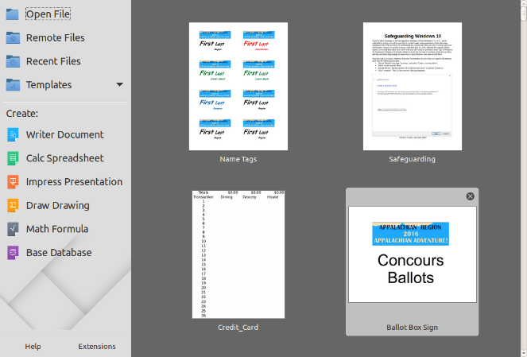
Screen 1. LibreOffice Startup.

Write is the LibreOffice word-processor, and is the only type of office application that many home users run (Screen 2). The two toolbars at the top are configurable, so you can populate them with the functions you use most often. The top one is the Standard Toolbar and is nearly the same for all LibreOffice applications. Below that is the Formatting Toolbar, which adapts to the current application. The right sidebar also changes according to what you are doing. In the screen-shot above, the cursor is on text and as a result the sidebar shows text styles. However, all the functions in the sidebar are also available on the menu bar and the toolbars, although accessing them may require several mouse clicks. My work requires little formatting, and as a result I usually keep the sidebar closed to allow more space for the document. Writer, like all the LibreOffice tools can be customized by adding, moving, and customizing toolbars, but this can become a tar pit. Be sure you are familiar with basic operation and carefully read a good tutorial before you venture too far into customizing.

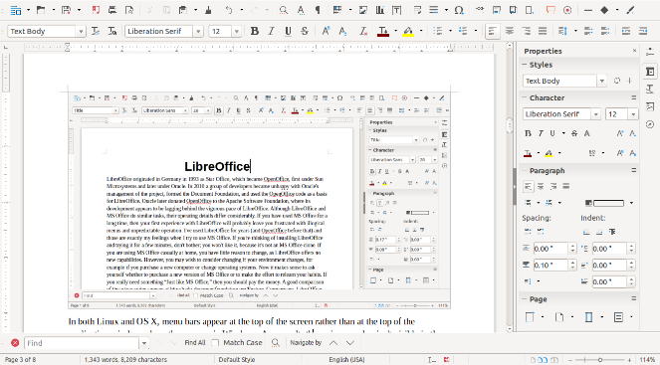
Screen 2. LibreOffice Write.

In both Linux and OS X, menu bars appear at the top of the screen rather than at the top of the application window where they appear in Windows. As a result, the main menu bar isn't visible in the above screen-shot. It appears below (Screen 3).

Screen 3. Write Menu Bar.

Like all LibreOffice applications, Writer can save files in several formats, as shown in the drop-down menu that appears when you select “Save as” (Screen 4).

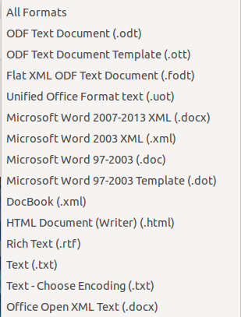
Screen 4. Save File Drop Down Menu.

I have not run into problems converting Writer documents to Microsoft doc and docx formats. I understand that converting the other way can be problematic, as Microsoft sometimes employs undocumented features, and this is true for all LibreOffice applications. The suite is evolving rapidly, and every version produces files that are more compatible with Microsoft's, although the latter are moving targets.

Calc is LibreOffice's spreadsheet application. Screen 5 shows one I put together to reconcile my credit card bills. Its menu and toolbars are quite similar to Writer's, although the individual functions differ of course. Here I show the sidebar closed, since i don't need it for this simple application. If you are familiar with Excel, you should quickly adapt to Calc, although if you will probably have to make some changes to the macros to move existing sheets to this new environment.

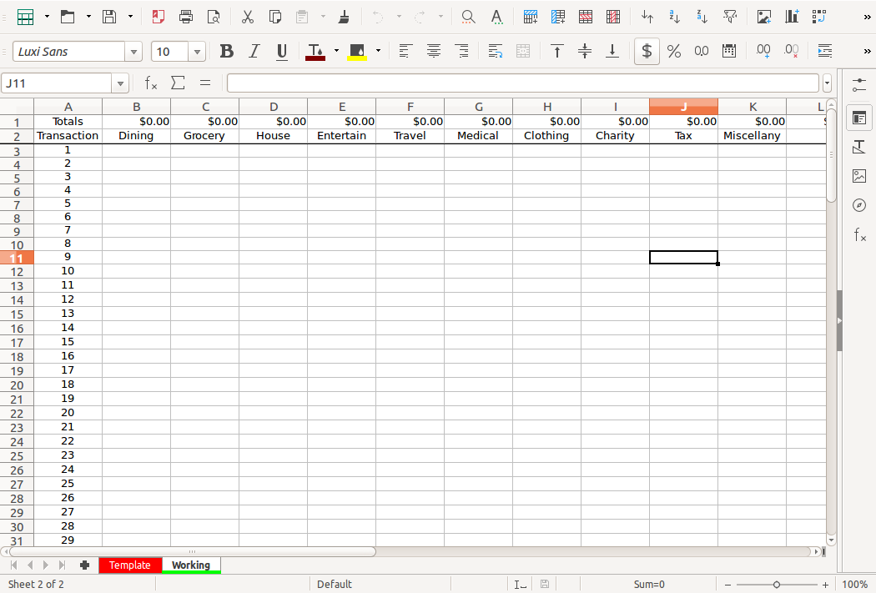
Screen 5. LibreOffice Calc.

It's presentation application is Impress. The screen-shot shows a PowerPoint file open in Impress. When I tried this some years ago, with OpenOffice (a predecessor of LibreOffice), there was considerable mangling of the slides. I've seen no evidence of this in the current LibreOffice. Nevertheless, be careful if you have an important presentation, and use the same program, and if possible the same operating system, to display it that you used to develop it. Screen 6 shows the program open in the notes view, so I can edit my lecture notes; the slide appears at the top of the screen and slide thumbnails in the left sidebar. Too many speakers either just read the slides to their audience or try to make up comments on the spot. Don't make this mistake; in preparing a talk, you should spend as much time preparing your remarks as your slides. You should also assume your audience can read; there is no reason to repeat the contents of the slides.

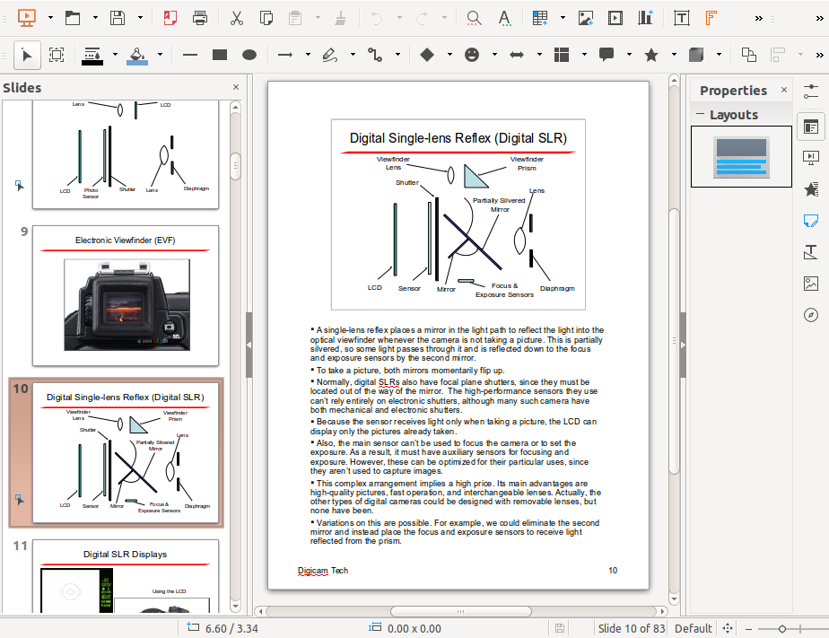
Screen 6. LibreOffice Impress.

Draw (Screen 7) is a simple drafting application, useful for creating figures for Writer and Impress. While both these applications have drafting functions, I find it easier to create figures with a dedicated program and then paste the results where I need them.

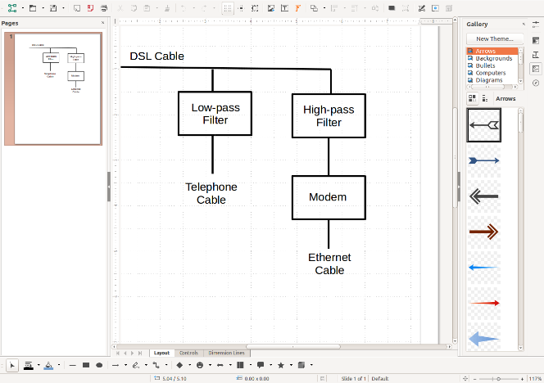
Screen 7. LibreOffice Draw.

Base (Screen 8) is the LibreOffice database application. The screen-shot shows a simple database for organizing photographs being developed using the wizard. I think too many people would use a spreadsheet for this, just because they are comfortable with it, when a database would be more appropriate. Another significant factor in the low usage of databases is that Access (the MS Office database application) is available only in the professional version and not at all for OS X. As a result, few home users have seen it.

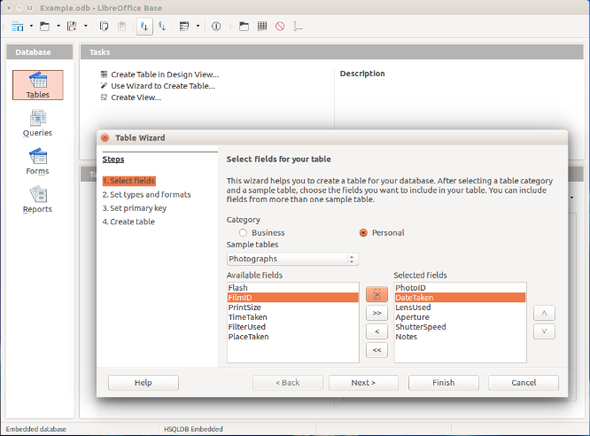
Screen 8. LibreOffice Base.

This has been a very brief introduction to LibreOffice. If you collaborate with others on complex office documents and they use MS Office, you may have an easier time if you use the same suite. I say “may” because the Mac and Windows versions of MS Office differ, and I've also had problems with incompatibilities among different versions of Windows Office. The only way to ensure compatibility is for all members of the team to use the same version of MS Office on the same operating system. By comparison, the code base of LibreOffice is the same for Windows, OS X, and Linux (for which MS Office is not available); if the members of your team use different operating systems, you will have fewer incompatibility problems than with MS Office. For most people, compatibility is not an issue, provided the LibreOffice users convert their files to Microsoft format.

That LibreOffice is open source brings some advantages. It costs nothing, so you can use it on as many computers as you like, and you can even install it on a memory stick for use on any PC, which allows you to use the same office suite wherever you go.

